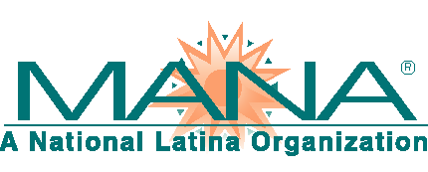
MANA, A National latina organization
1140 19th Street, NW, Suite 550, Washington, DC 20036 202-525-5113 www.hermana.org

FOR IMMEDIATE RELEASE Contact: Amy Hinojosa
ahinojosa@hermana.org

MANA to Congress: Unacceptable to Use Dreamers as Pawns
DACA Protected Individuals Deserve More Than Empty Promises

Washington, DC – January 22, 2018 – As the United States Senate came to a compromise on current spending today, ending a 3-day federal government shut down, it became immediately evident that young people with DACA status were left as pawns for the next round of political posturing. The compromise was to hold a determinative vote in the Senate on DACA by February 8. Even if the Senate passes a reasonable solution for DACA, this compromise provides no guarantee of agreement from the House of Representatives, nor any indication that the President would sign it into law.

Individuals with DACA protected status were brought to this country, through no fault of their own, as children. With the promise of no retaliation, they came out of the shadows to register for DACA protections, undergo extensive criminal background checks and continue to either work or go to school. These Dreamers are Americans by every possible measure, as they know no other home.

“Once again, the Hispanic community was cast aside for political expediency and Dreamers were left with no more of a promise for tomorrow than they’ve had from the moment the President rescided DACA protections. The DACA debate was thrown into turmoil because of offensive racial terminology used during the negotiations. We have made no progress in that time, yet are supposed to believe that a solution will both magically appear and miraculously pass through all chambers in the next three weeks,” said MANA President and CEO, Amy Hinojosa. She concludes, “Leaders of all political leanings must now recognize that they hold the lives of 800,000 law-abiding and upstanding youth in their hands. They cannot allow time to expire again without a resolution. History is watching.”

###
Founded in 1974, MANA, A National Latina Organization® (MANA) is a national grassroots membership organization with chapters, individual members and affiliates across the country. MANA represents the interests of Latina women, youth and families on issues that impact our communities. The MANA mission is to empower Latinas through leadership development, community service, and advocacy. This is accomplished nationally through the AvanZamos® educational initiatives for adults and the Hermanitas® mentoring program for Latina youth, ages 11-18.

